Selenium Setup

Contents

1. Install JDK 2

2. Set Environment Variables 2

3. Install Eclipse 5

4. Install Maven 6

5. Install TestNG 9

|  |  |  |  |
| --- | --- | --- | --- |
| Author(s) | Version | Published Date | Modified |
| Hemalatha Penti | 1.0 | 04/12/2020 | Initial version |

**Please make sure you are installing the software with Elevated privileges.**

# Install JDK

Download JDK zip from Software House and install on your machine. While installing please note the path where you are installing. We need the path in next steps.

It displays the below message if it is already installed, else please continue with the steps and complete the installation.

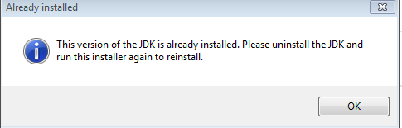

To confirm JAVA is installed correctly on your machine, open command prompt and type command ‘java -version’ and Enter, it will give the java version installed on your machine as below:

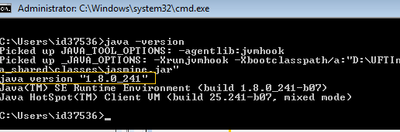

# Set Environment Variables

Right Click on ‘**Computer’** and choose **Properties.** Click on ‘**Advanced system settings**’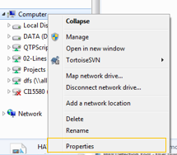

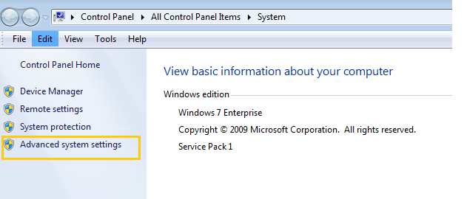

Click on Advanced Tab -> Click on Environment Variables

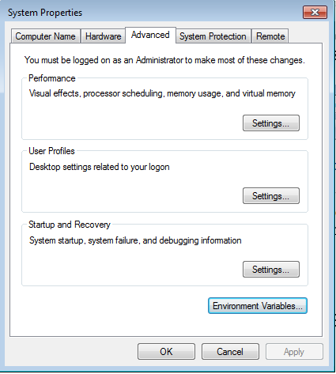

Click on ‘New’ under System variables:

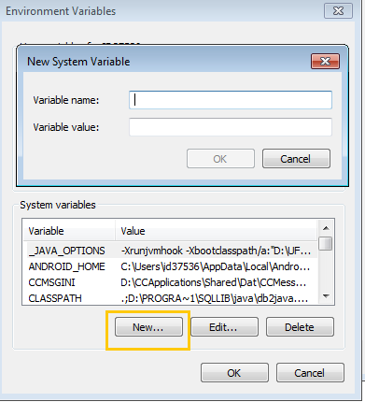

Give Variable Name as JAVA_HOME and value should be the path from your computer where JDK is installed and then click on OK

For Example: “C:\Program Files\Java\jdk1.8.0_231;” (Please copy this path from your machine, it may vary based on the location you installed JDK)

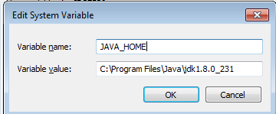

Next, click on Path variable under system variables and click on edit

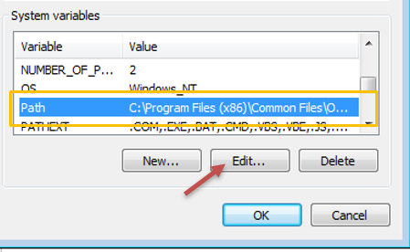

Append JDK path to the existing variable value like below:

For example: “;C:\Program Files\Java\jdk1.8.0_231;” (Please copy this path from your machine, it may vary for you based on the location you installed JDK)

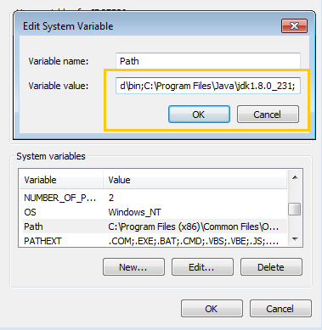

Download chrome driver from Internet and place in your local drive:

Add chrome driver path in variable value text box:

For Example, “;D:\ChromeDriver“

Click on OK -> OK on environment variables window

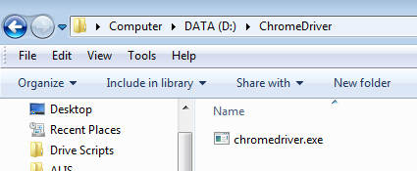 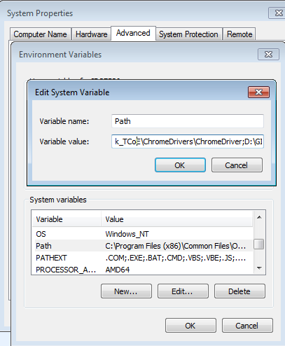

# Install Eclipse

Download Eclipse zip file from the shared path, unzip to your local drive .

Once you unzip, you should see the below files under eclipse folder.

Double click on eclipse.exe

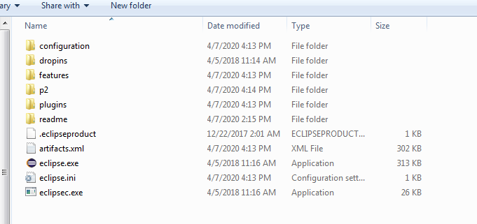

click **Launch** on Eclipse Launch Screen.

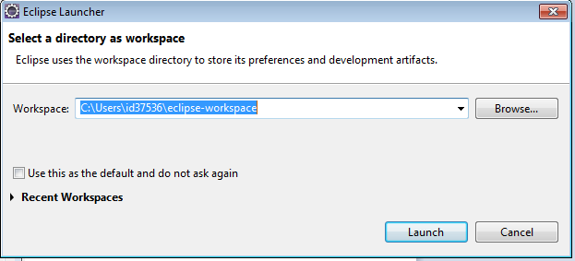

Eclipse IDE will be opened, and it is ready to use.

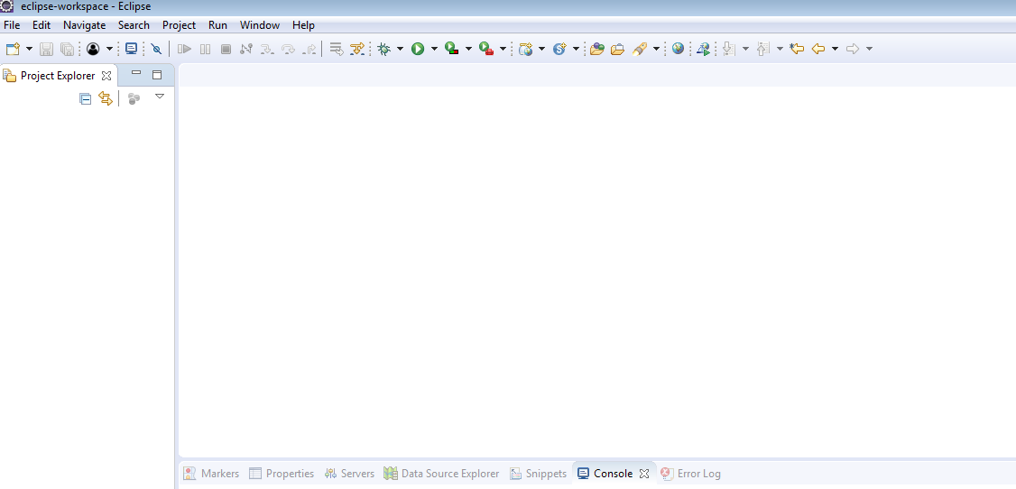

# Install Maven

Click on the **Help** from the top menu in **Eclipse** and select ‘**Install New Software…**‘

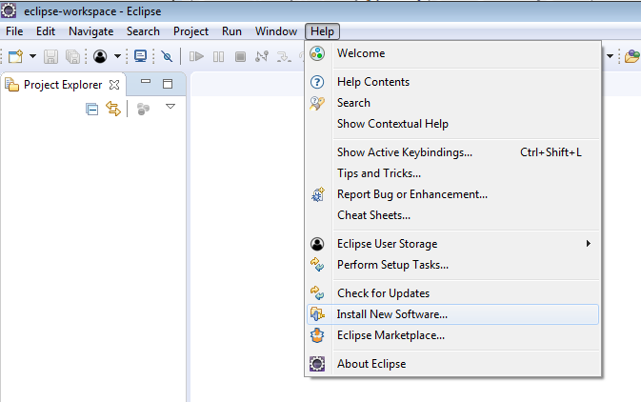

Click on the **Add**button on the Install window.

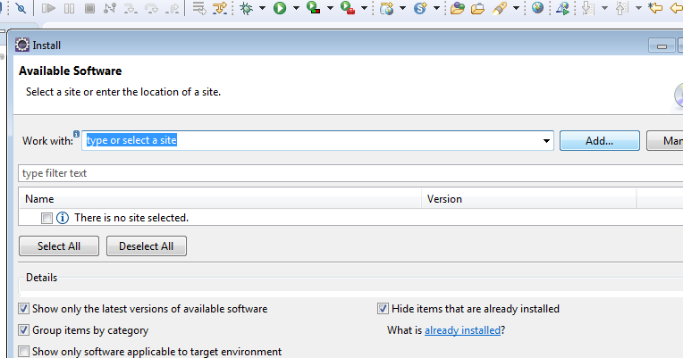

In the Name box, type ‘**Maven**‘ and in the Location box, type ‘**http://download.eclipse.org/technology/m2e/releases/**‘ and click on OK

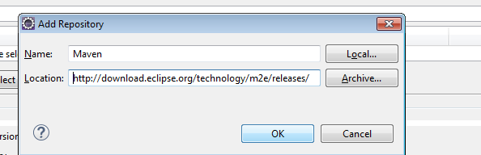

A checkbox will appear in the pop window, **Check** the checkbox and clickon **Next** button.

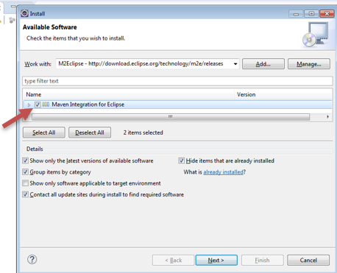

After clicking on Next , it will take some time to install. The below second window will appear once it is installed. Keep the default radio button selection and click on Next .

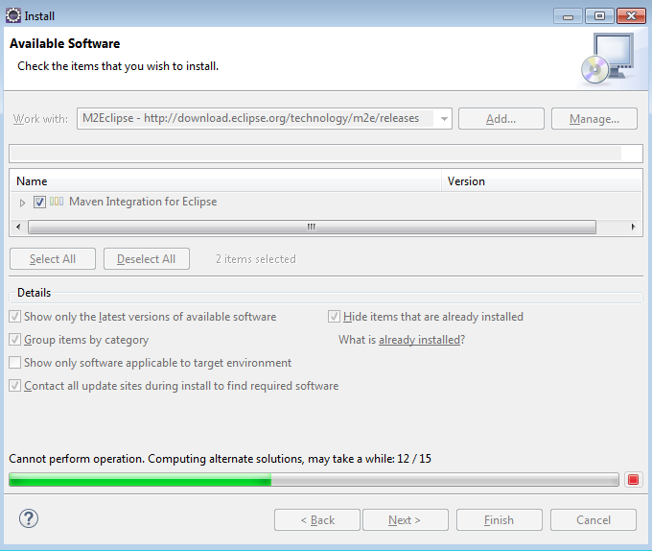 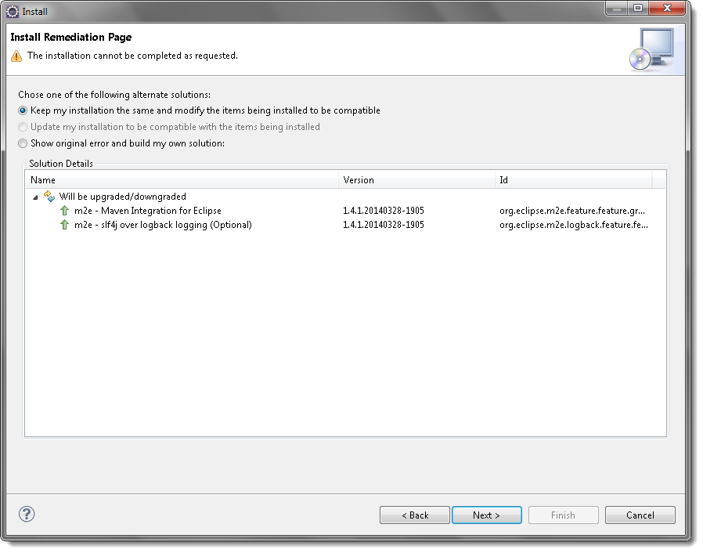

Accept Terms of the License agreement and click on Finish.

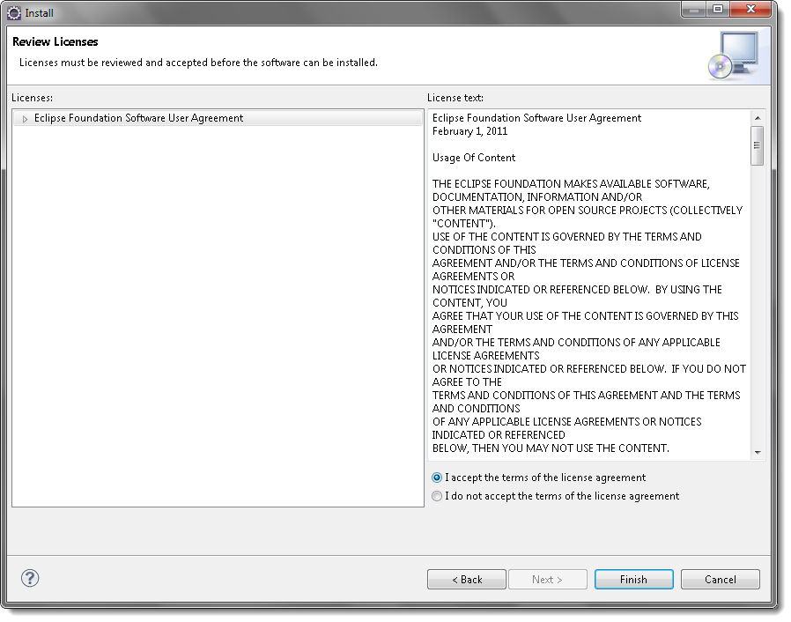

Wait till the installation finishes and click on Yes to restart eclipse:

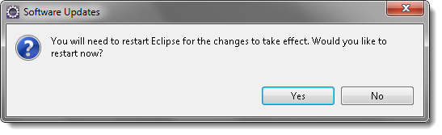

# Install TestNG

Click on the **Help** from the top menu in **Eclipse** and select ‘**Install New Software..**‘

In the Name box, type ‘**TestNG** ‘and in the Location box,

type ‘http://dl.bintray.com/testng-team/testng-eclipse-release/‘ and click on OK

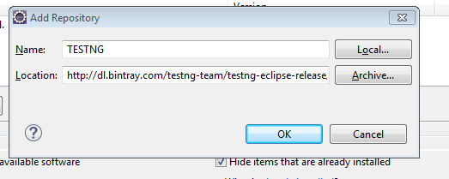

Select only one checkbox as shown below and click on Next

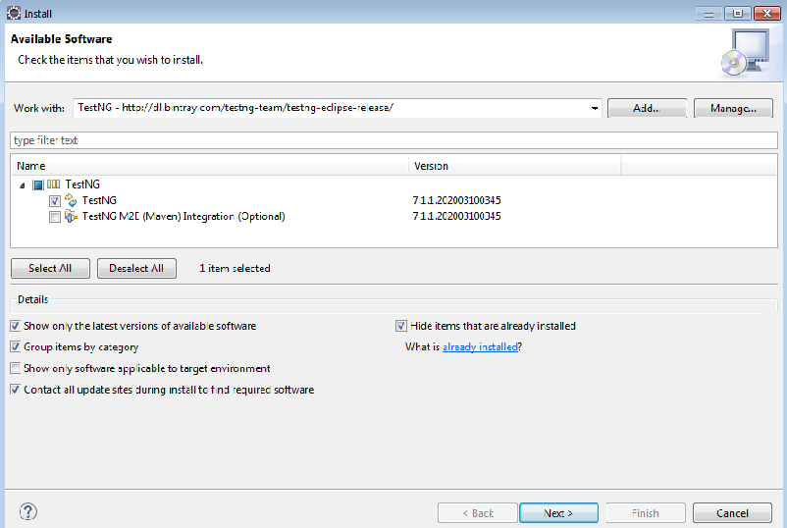

Click on Confirm on Next screen:

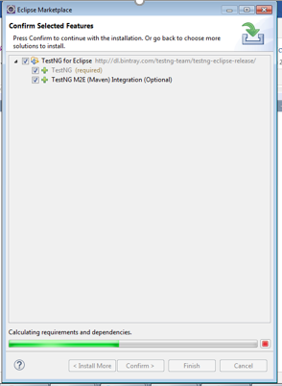

Click on Confirm to complete installation

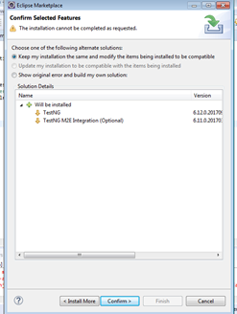

On next screen accept the terms of license and click on Next.

Then click on Restart Now option on the window.